**Step 1**: Open up a new browser and paste the link [http://ftp.mozilla.org/pub/mozilla.org/firefox/releases/21.0/win32/en-US/Firefox%20Setup%2021.0.exe](http://ftp.mozilla.org/pub/mozilla.org/firefox/releases/21.0/win32/en-US/Firefox%20Setup%2021.0.exe%20) onto the address bar. Press enter when finished.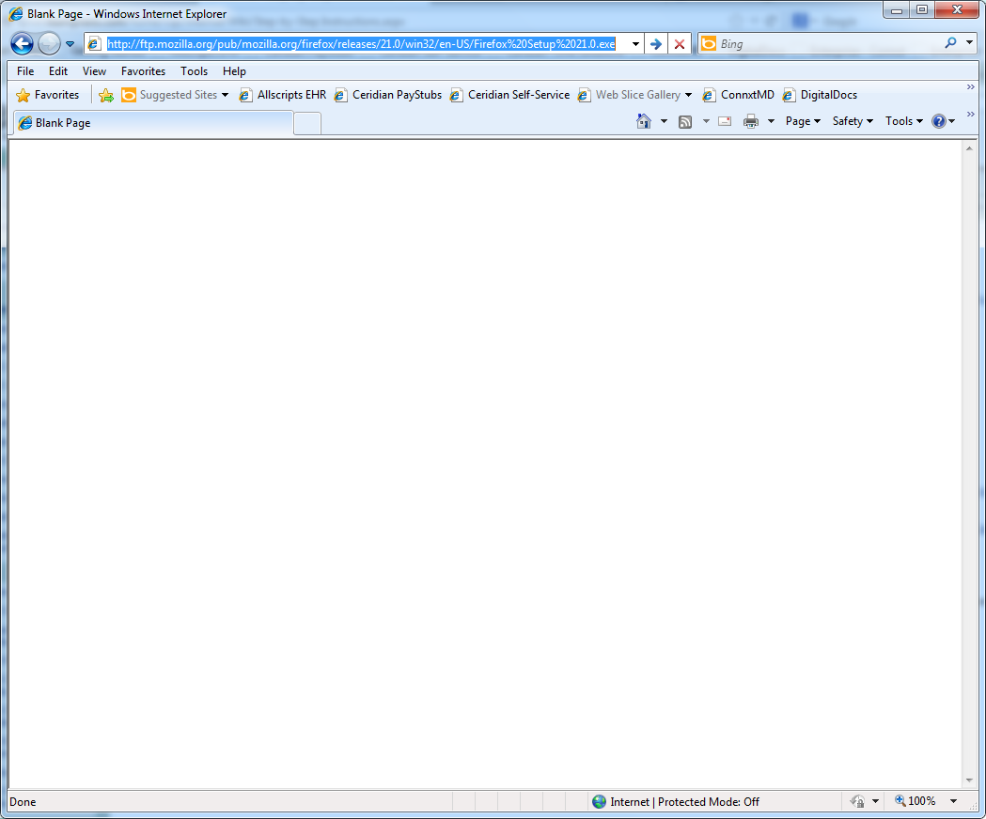

**Step 2**: Click on the Save button and save Firefox Setup 21.0 to your desktop.

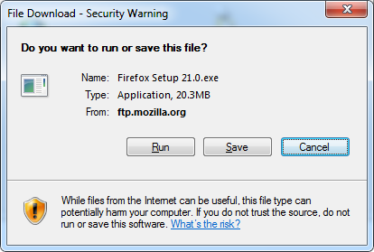

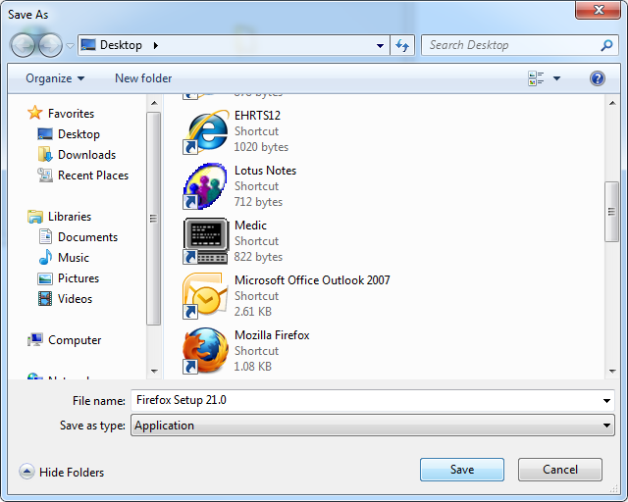

**Step 3**: Launch Firefox Setup 21.0 from your desktop.

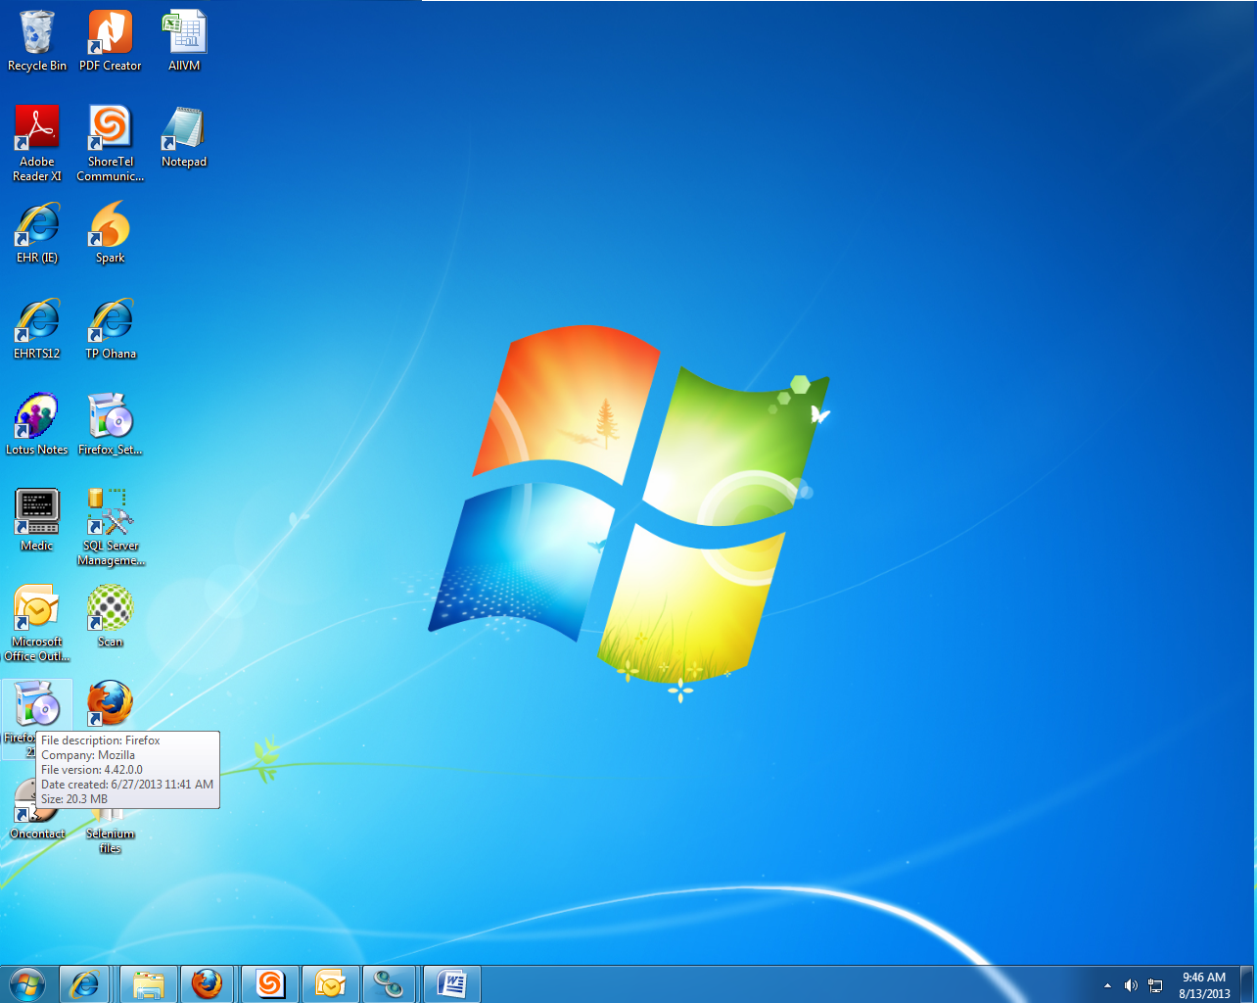

**Step 4**: Click on the run button once the Security Warning pops up. 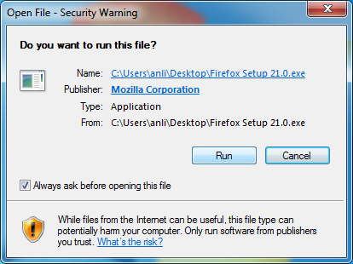

**Step 5**: Wait for the Mozilla Firefox Setup to show up. Then, complete the wizard.

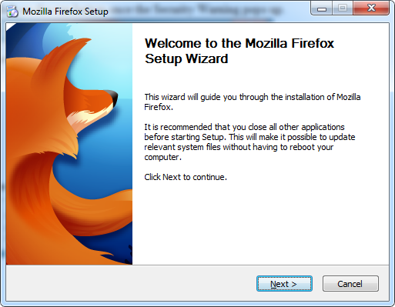 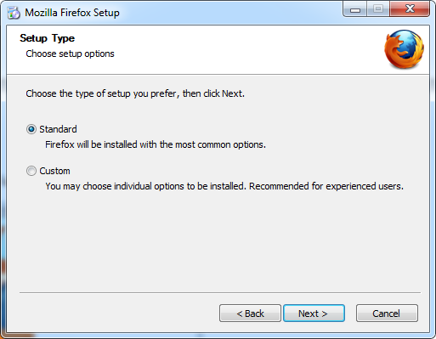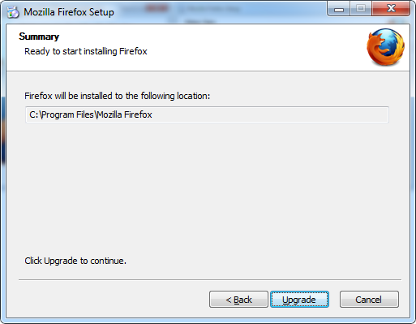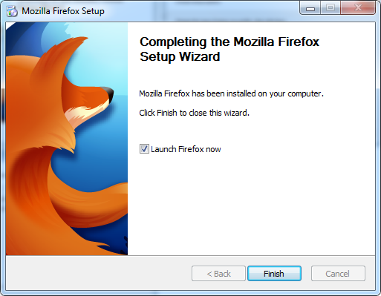

**Step 6**: If you have not already launched firefox, do so. Go to the site <https://addons.mozilla.org/en-US/firefox/addon/firebug/>. Click on the Add to Firefox button and install the [Firebug 1.11.4](https://addons.mozilla.org/firefox/downloads/latest/1843/addon-1843-latest.xpi?src=dp-btn-primary) addon.

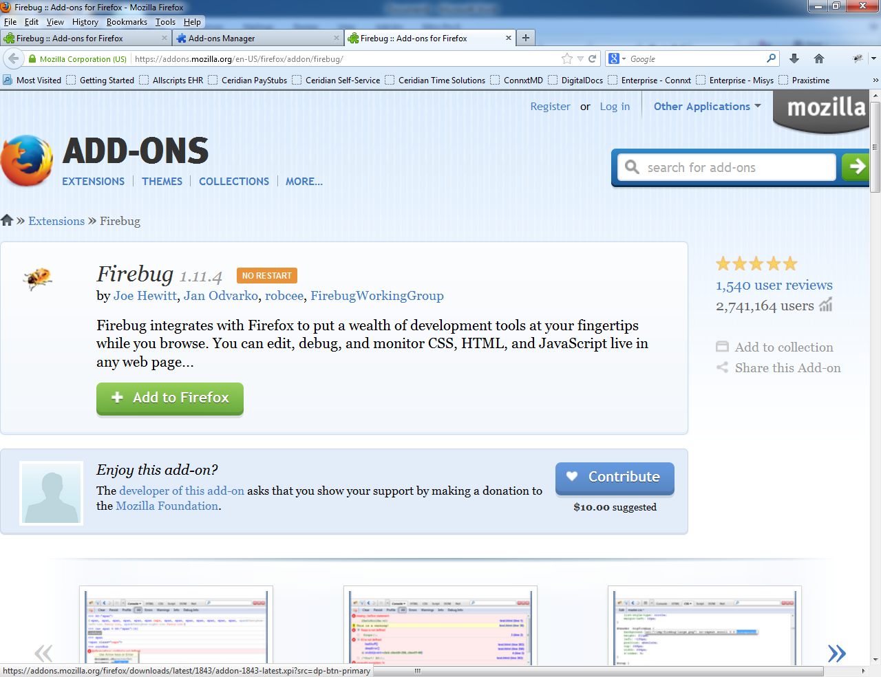

**Step 7**: Go to the site <http://release.seleniumhq.org/selenium-ide/2.2.0/selenium-ide-2.2.0.xpi> and install Selenium IDE and all of the formatters.

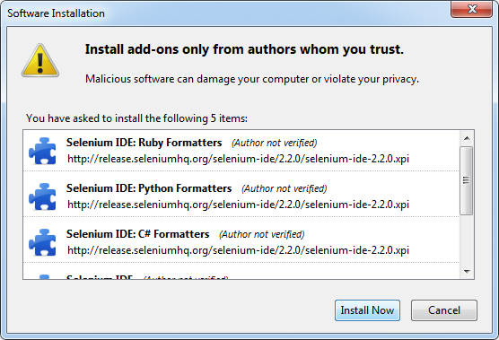

**Step 8:** Go to the site <https://addons.mozilla.org/firefox/downloads/latest/177844/addon-177844-latest.xpi?src=dp-btn-primary> and install the File Logging plugin for Selenium IDE. 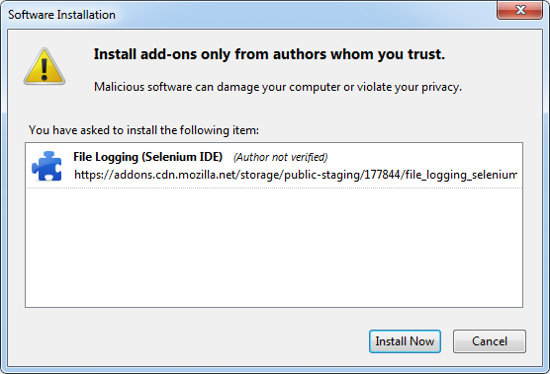

**Step 9**: Enable the Firefox add-ons if they are disabled. 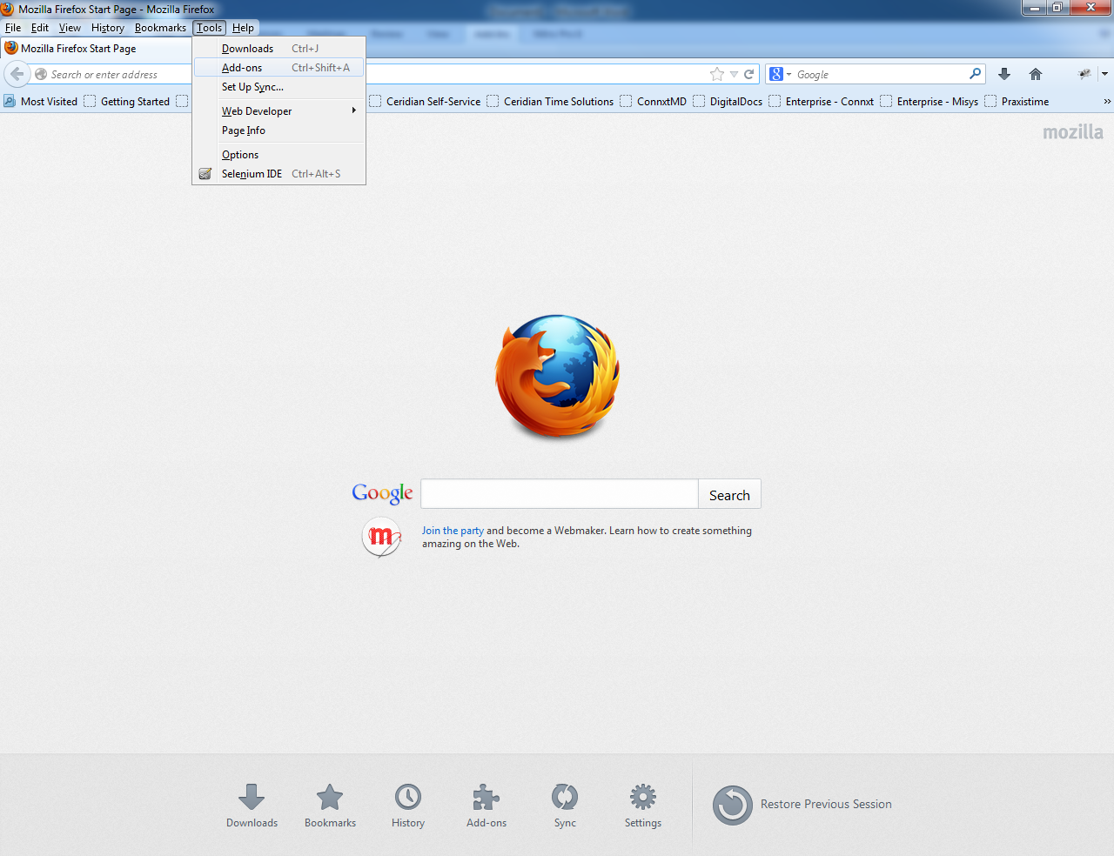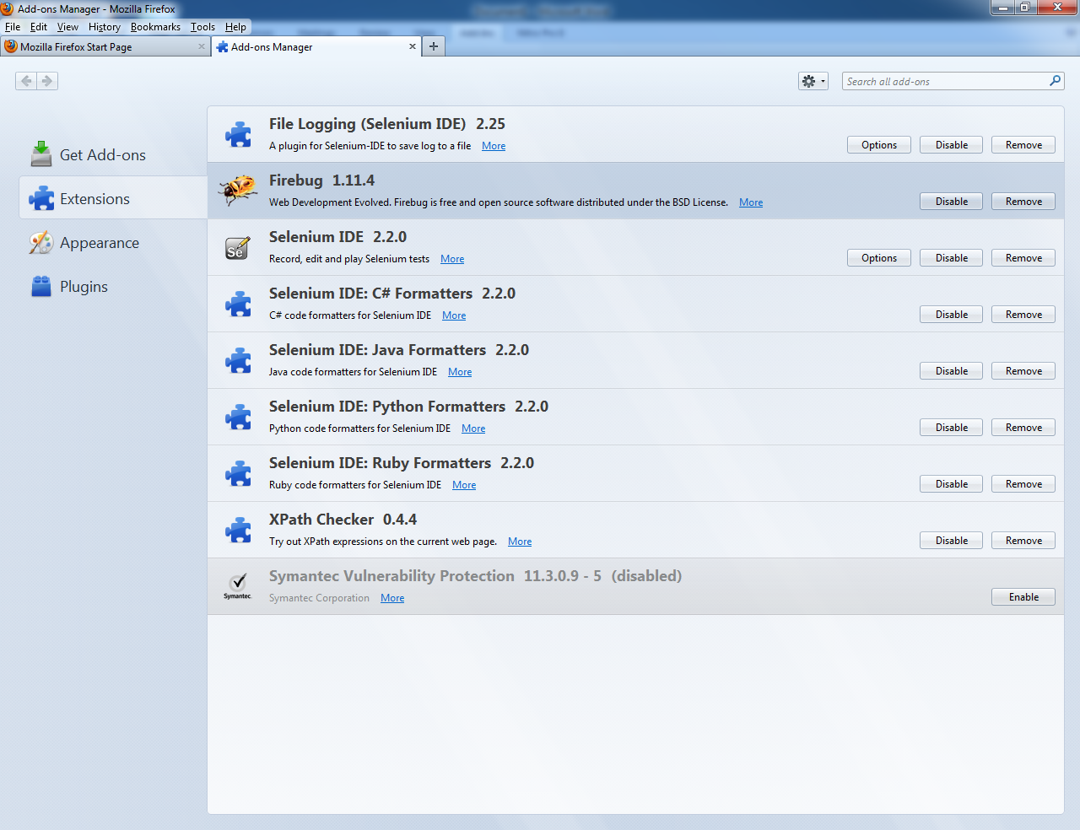

**Step 10**: Open notepad and copy and paste the following text:

Selenium.prototype.doClickIfPresent = function(locator)

{

if (selenium.isElementPresent(locator) == true)

this.page().findElement(locator).click();

}

Selenium.prototype.doErrorIfElementPresent = function(locator, text)

{

if (selenium.isElementPresent(locator) == true)

throw new Error("\n-----------------------------------------------------------------\n"

+ text +

"\n-----------------------------------------------------------------\n");

}

Selenium.prototype.doErrorIfElementNotPresent = function(locator, text)

{

if (selenium.isElementPresent(locator) == false)

throw new Error("\n----------------------------------------------------------------\n"

+ text +

"\n----------------------------------------------------------------\n");

}

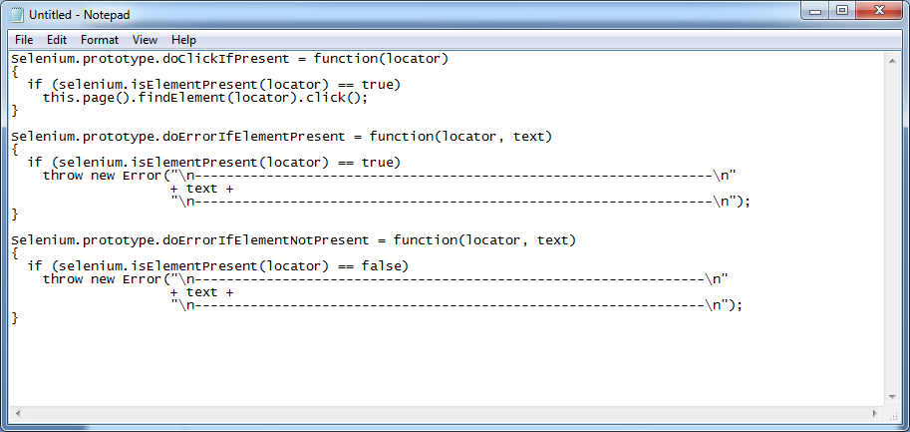

**Step 11**: Save this file to your computer. Make sure you change the type to “All Files” and end the file with (.js). You’ll need the file later.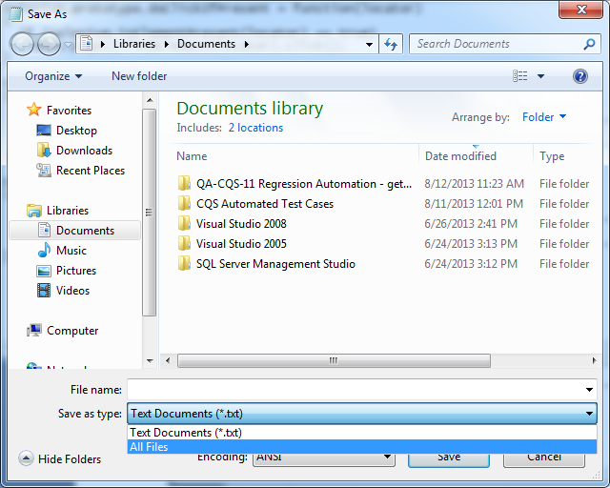

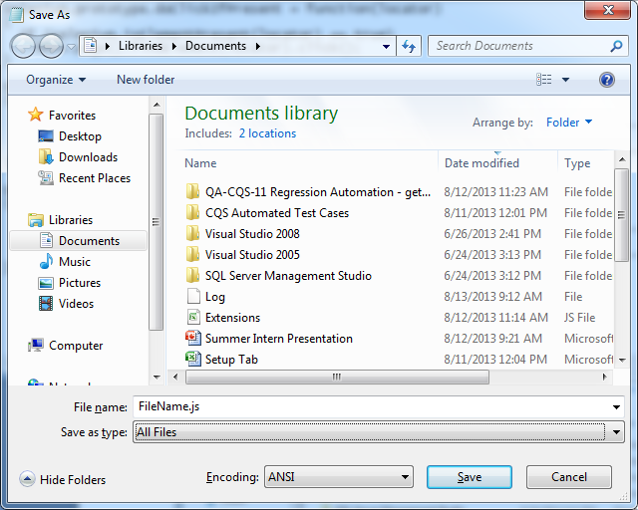

**Step 12**: Open up Firefox 21.0. Go to tools and then click on Selenium IDE.

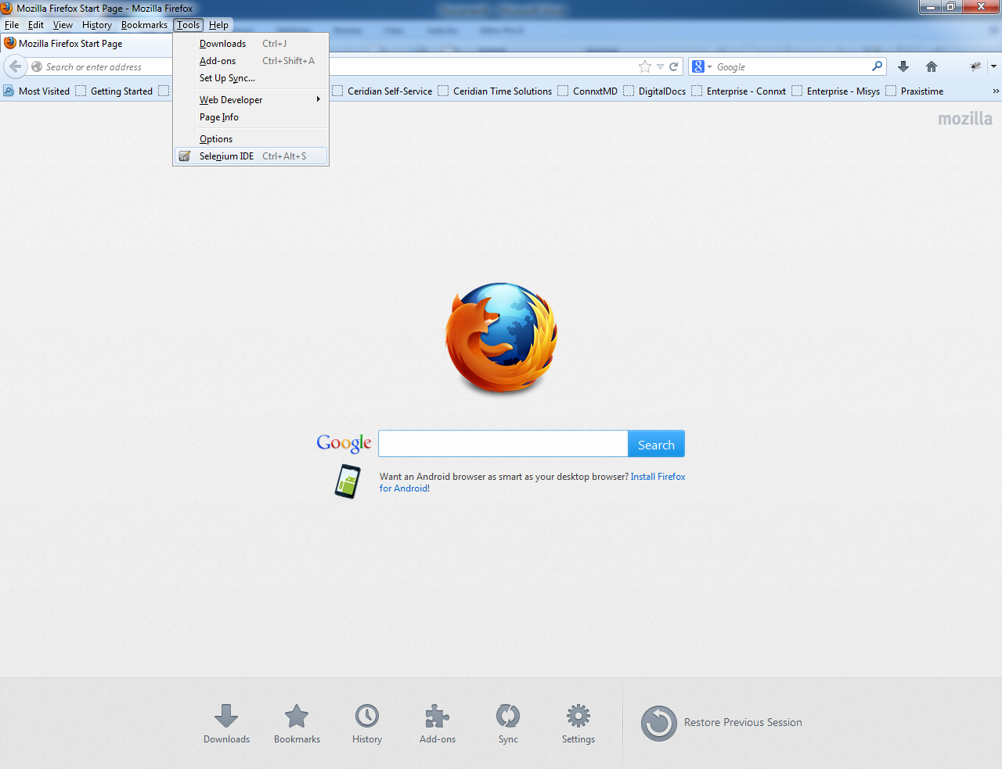

**Step 13**: Now go to the options menu and select on options.

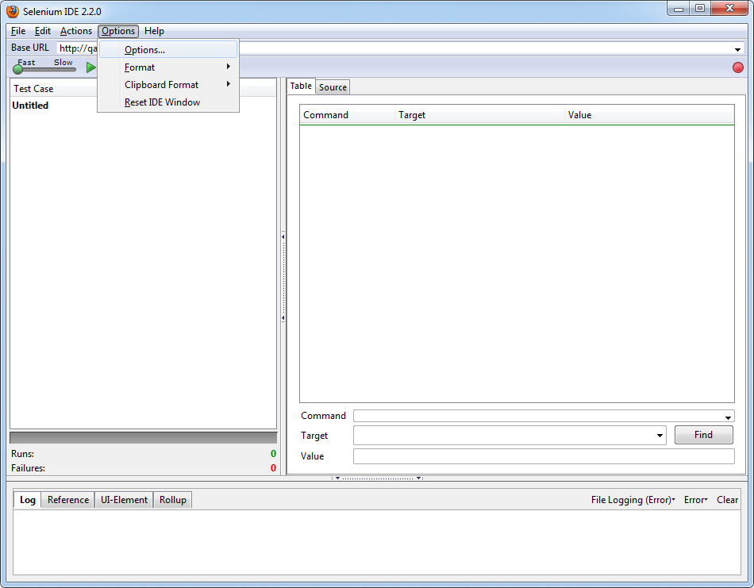

**Step 14**: Under Selenium Core extensions, click on browse. Open the file you created earlier.

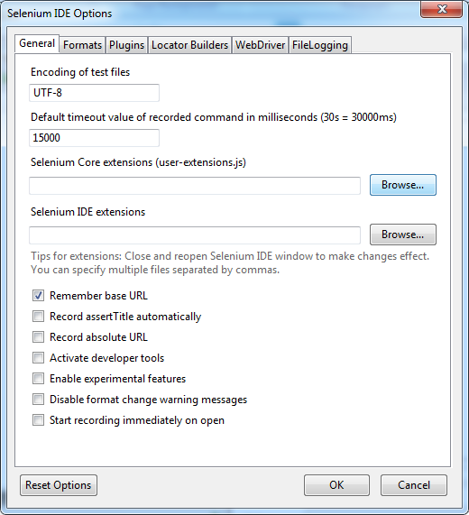

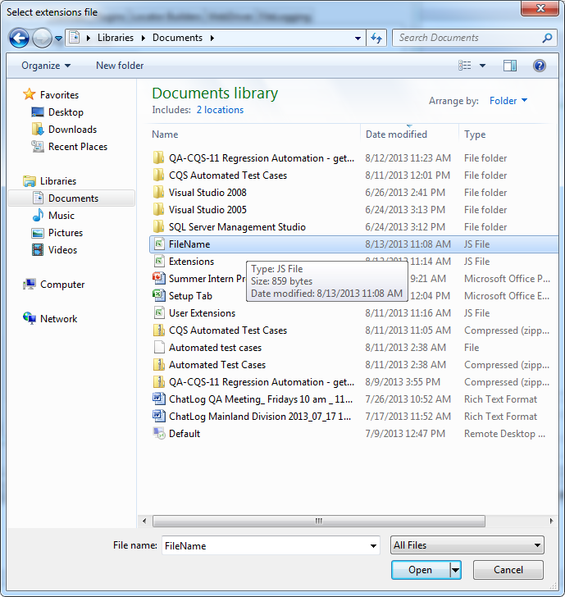

**Step 15**: Switch over to the FileLogging tab and click on the Browse button. Type in a name for your Log file and then click on the save button.

.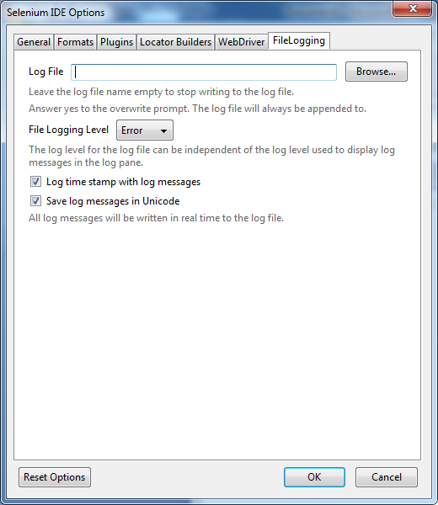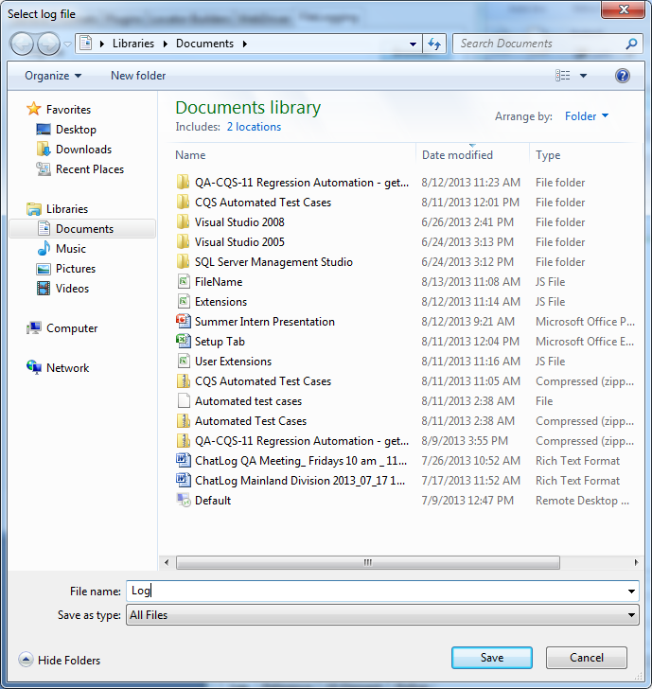

**Step 16**: Click on the OK button and close the Selenium IDE window.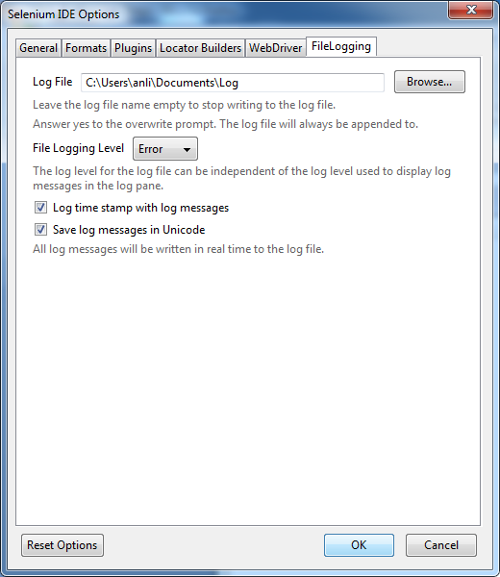

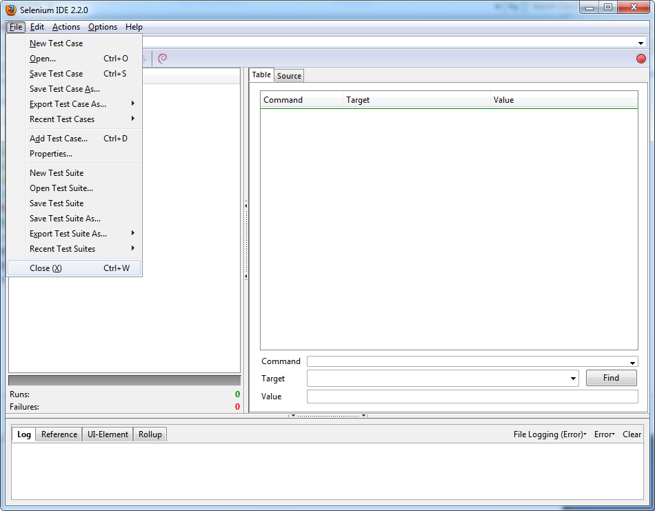

**Step 17**: Download all the Selenium test cases and suites on tpnet. Open it with Windows Explorer.

[CQS](http://tpnet.teampraxis.com/home/cqs/default.aspx) > [Internal](http://tpnet.teampraxis.com/home/cqs/internal/default.aspx) > [Test Documentation](http://tpnet.teampraxis.com/home/cqs/internal/Test%20Documentation/Forms/AllItems.aspx?RootFolder=%2fhome%2fcqs%2finternal%2fTest%20Documentation%2fRegression%20Testing&FolderCTID=&View=%7bA80C2368%2dB512%2d41CA%2d976D%2d25F5EF9EFC4B%7d) > [Regression Testing](http://tpnet.teampraxis.com/home/cqs/internal/Test%20Documentation/Forms/AllItems.aspx?RootFolder=%2fhome%2fcqs%2finternal%2fTest%20Documentation%2fRegression%20Testing&FolderCTID=&View=%7bA80C2368-B512-41CA-976D-25F5EF9EFC4B%7d) > [CQS Automated Test Cases](http://tpnet.teampraxis.com/home/cqs/internal/Test%20Documentation/Regression%20Testing/CQS%20Automated%20Test%20Cases.zip)

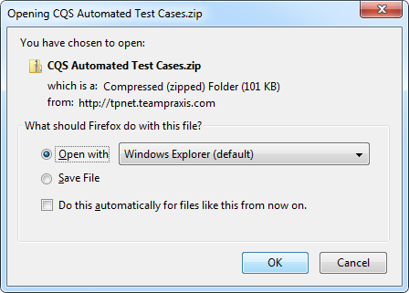

**Step 18**: Move the folder with the Selenium test cases and suites over to the documents folder.

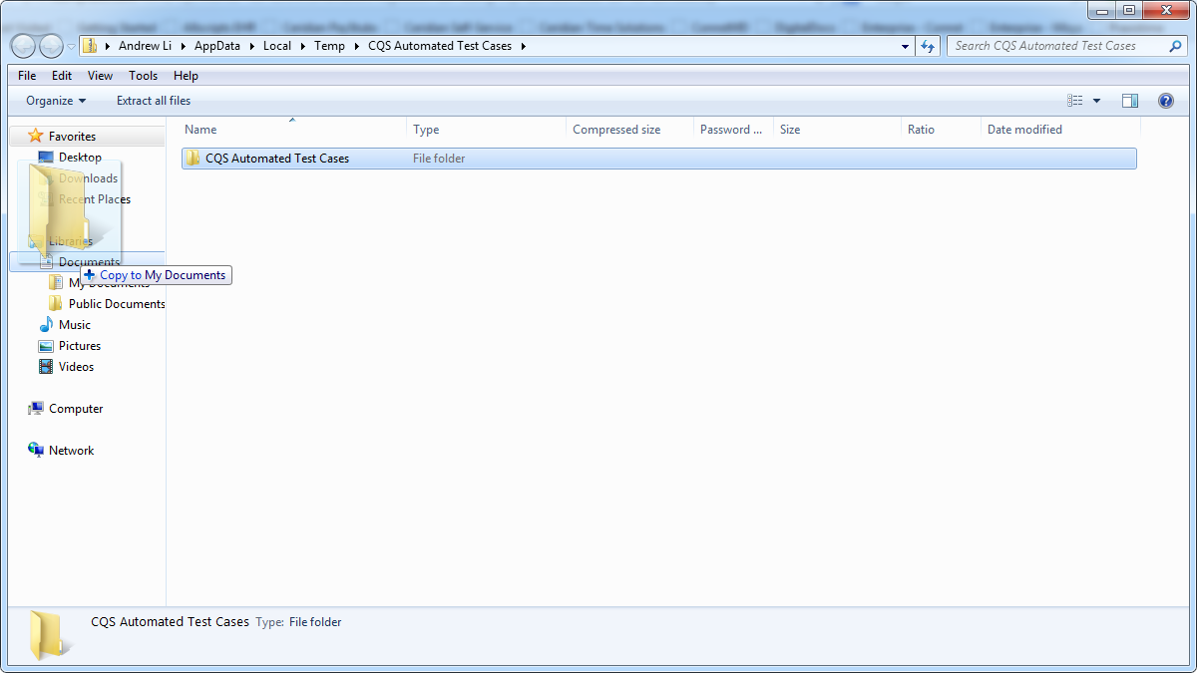

**Step 19**: Open up Selenium IDE again. Go to file > open.



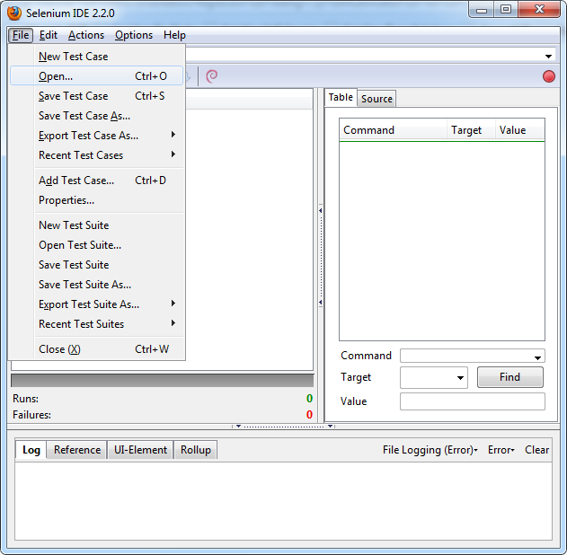

**Step 20**: Open up the folder that with the test cases and test suites that you downloaded from tpnet. Open up the desired test suite or test case.

